Pizza Sales Project
KPI Requirements
1.Total Revenue
select SUM(total_price) AS Total_Revenue from pizza_sales
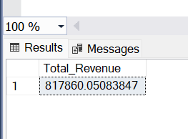
2.Average Order values
select SUM(total_price)/count(DISTINCT order_id) AS Average_order_value from pizza_sales
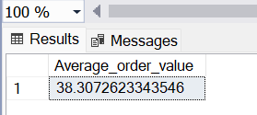
3.Total pizza sold
select SUM(quantity) AS Total_Pizza_Sold from pizza_sales
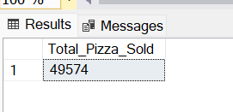
4.Total Orders
select COUNT(DISTINCT order_id) AS Total_Orders from pizza_sales
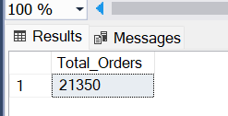
5.Average Pizza per order
select CAST(CAST(SUM(quantity) AS DECIMAL(10,2)) / CAST(COUNT(DISTINCT order_id) AS DECIMAL(10,2)) AS DECIMAL(10,2)) AS Average_Pizza_Per_Order from pizza_sales
